**PRACTICAL NO: 3**

**THEORY:**

**Configure network for Dynamic Routing for following Protocol**

A Routing Protocol is a protocol that specifies how routers communicate with each other, disseminating information that enables them to select routes between any two nodes on a computer network. Routing algorithms are responsible for selecting the best path for the communication a border way we can say that A routing protocol is the language a router speaks with other routers in order to share information about the reach ability and status of network

1. **Routing Information Protocol (RIP) :-** Routing information protocol is a standards-based, distance-vector, interior gateway protocol used by routers to trade routing information. Interior gateway means it should be used for the routers in same domain network . The metric used in RIP to find out the best path between two locations is Hop count. Hop count is the number of routers the packet must go through till it reaches the destination network. The maximum allowable number of hops a packet can go across in an IP network implementing RIP is 15 hops. Routers using RIP publicize information about each subnet to their neighbours. Their neighbour in turn passes the information to the nearby neighbours of their own and so on until all the routers are alert of information.
2. **Open Shortest Path First (OSPF) :-** Open Shortest Path First (OSPF) is a link-state routing protocol and. It computes the shortest path tree for each route using a method based on Dijkstra algorithm, a shortest path first algorithm. This interior gateway protocol (IGP) is most popular in large enterprise networks. OSPF is used to determine the best route for delivering the packets within an IP networks.
3. **Enhanced Interior Gateway Routing Protocol (EIGRP) :-** The Enhanced Interior Gateway Routing Protocol (EIGRP) is an enhancement of IGRP. A hybrid routing protocol which provides significant improvements on IGRP. EIGRP replaced IGRP in 1993. It having a higher convergence than any other IGP and it is scalable because of VLSM and route information. To implement the routing the EIGRP maintains three unique tables to assist in routing traffic, they are neighbour table, topology table and routing table.

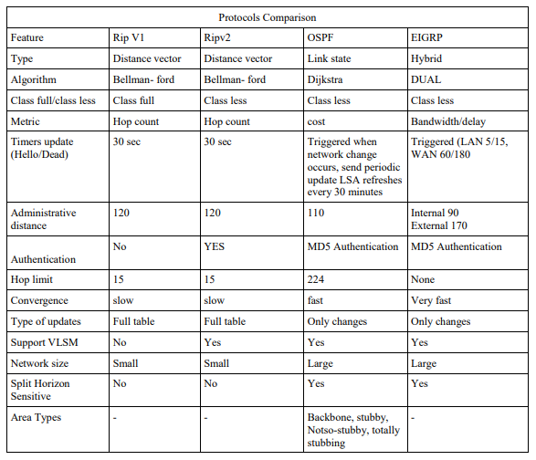

**B)**

**Aim: Configure network for dynamic routing using the following protocols**

**Step 1: Create Network and assign IP address.**

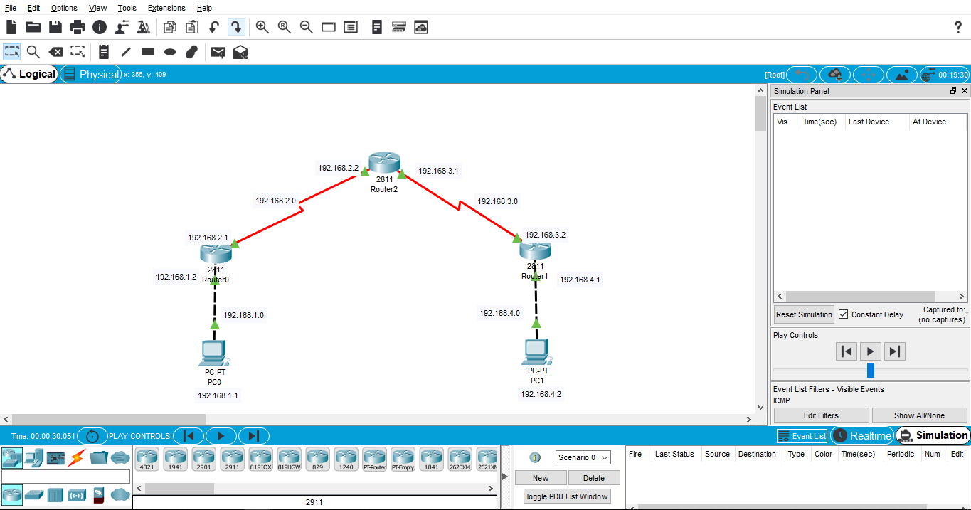

**Step 2 : Configure router as shown below take first protocol RIPv1**

**a. RIPv1**

**Step 3: Configure Routers as shown below**

**CLI router0:**

Router>en

Router#config t

Enter configuration commands, one per line. End with CNTL/Z.

Router(config)#router rip

Router(config-router)#network 192.168.1.0

Router(config-router)#network 192.168.2.0

Router(config-router)#

**CLI router1:**

Router>en

Router#config t

Enter configuration commands, one per line. End with CNTL/Z.

Router(config)#router rip

Router(config-router)#network 192.168.3.0

Router(config-router)#network 192.168.4.0

Router(config-router)#

**CLI router2:**

Router>en

Router#config t

Enter configuration commands, one per line. End with CNTL/Z.

Router(config)#router rip

Router(config-router)#network 192.168.2.0

Router(config-router)#network 192.168.3.0

Router(config-router)#

**Step 4: Check the connections of routers after configuration as shown below (using commands)**

**Show Router0 route:**

Router>show ip route

Codes: C - connected, S - static, I - IGRP, R - RIP, M - mobile, B - BGP

D - EIGRP, EX - EIGRP external, O - OSPF, IA - OSPF inter area

N1 - OSPF NSSA external type 1, N2 - OSPF NSSA external type 2

E1 - OSPF external type 1, E2 - OSPF external type 2, E - EGP

i - IS-IS, L1 - IS-IS level-1, L2 - IS-IS level-2, ia - IS-IS inter area

* - candidate default, U - per-user static route, o - ODR

P - periodic downloaded static route

Gateway of last resort is not set

C 192.168.1.0/24 is directly connected, FastEthernet0/0

C 192.168.2.0/24 is directly connected, Serial0/3/0

R 192.168.3.0/24 [120/1] via 192.168.2.2, 00:00:02, Serial0/3/0

R 192.168.4.0/24 [120/2] via 192.168.2.2, 00:00:02, Serial0/3/0

**Show Router1 route:**

Router>show ip route

Codes: C - connected, S - static, I - IGRP, R - RIP, M - mobile, B - BGP

D - EIGRP, EX - EIGRP external, O - OSPF, IA - OSPF inter area

N1 - OSPF NSSA external type 1, N2 - OSPF NSSA external type 2

E1 - OSPF external type 1, E2 - OSPF external type 2, E - EGP

i - IS-IS, L1 - IS-IS level-1, L2 - IS-IS level-2, ia - IS-IS inter area

* - candidate default, U - per-user static route, o - ODR

P - periodic downloaded static route

Gateway of last resort is not set

R 192.168.1.0/24 [120/2] via 192.168.3.1, 00:00:07, Serial0/3/0

R 192.168.2.0/24 [120/1] via 192.168.3.1, 00:00:07, Serial0/3/0

C 192.168.3.0/24 is directly connected, Serial0/3/0

C 192.168.4.0/24 is directly connected, FastEthernet0/0

**Show Router2 route:**

Router>show ip route

Codes: C - connected, S - static, I - IGRP, R - RIP, M - mobile, B - BGP

D - EIGRP, EX - EIGRP external, O - OSPF, IA - OSPF inter area

N1 - OSPF NSSA external type 1, N2 - OSPF NSSA external type 2

E1 - OSPF external type 1, E2 - OSPF external type 2, E - EGP

i - IS-IS, L1 - IS-IS level-1, L2 - IS-IS level-2, ia - IS-IS inter area

* - candidate default, U - per-user static route, o - ODR

P - periodic downloaded static route

Gateway of last resort is not set

R 192.168.1.0/24 [120/1] via 192.168.2.1, 00:00:04, Serial0/3/0

C 192.168.2.0/24 is directly connected, Serial0/3/0

C 192.168.3.0/24 is directly connected, Serial0/2/0

R 192.168.4.0/24 [120/1] via 192.168.3.2, 00:00:17, Serial0/2/0

**Step 5 : Check the connections of routers after configuration (without using commands)**

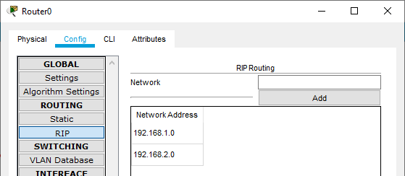

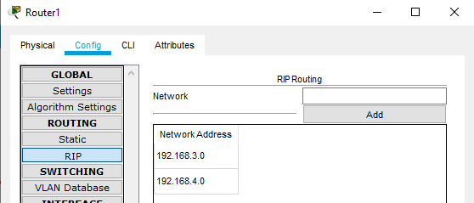

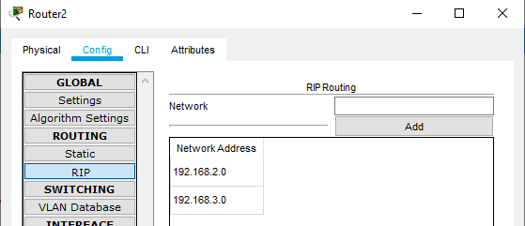

**Step 6: Take next protocol RIPv2**

**b. RIPv2**

**Step 7: Configure Routers as shown below**

**CLI router0:**

Router>en

Router#config t

Enter configuration commands, one per line. End with CNTL/Z.

Router(config)#router rip

Router(config-router)#version 2

Router(config-router)#network 192.168.1.0

Router(config-router)#network 192.168.2.0

**CLI router1:**

Router>en

Router#config t

Enter configuration commands, one per line. End with CNTL/Z.

Router(config)#router rip

Router(config-router)#version 2

Router(config-router)#network 192.168.3.0

Router(config-router)#network 192.168.4.0

**CLI router2:**

Router>en

Router#config t

Enter configuration commands, one per line. End with CNTL/Z.

Router(config)#router rip

Router(config-router)#version 2

Router(config-router)#network 192.168.2.0

Router(config-router)#network 192.168.3.0

**Step 8: Check the connections of routers after configuration as shown below (using commands)**

**Show Router0 route:**

Router>show ip route

Codes: C - connected, S - static, I - IGRP, R - RIP, M - mobile, B - BGP

D - EIGRP, EX - EIGRP external, O - OSPF, IA - OSPF inter area

N1 - OSPF NSSA external type 1, N2 - OSPF NSSA external type 2

E1 - OSPF external type 1, E2 - OSPF external type 2, E - EGP

i - IS-IS, L1 - IS-IS level-1, L2 - IS-IS level-2, ia - IS-IS inter area

* - candidate default, U - per-user static route, o - ODR

P - periodic downloaded static route

Gateway of last resort is not set

C 192.168.1.0/24 is directly connected, FastEthernet0/0

C 192.168.2.0/24 is directly connected, Serial0/3/0

R 192.168.3.0/24 [120/1] via 192.168.2.2, 00:00:27, Serial0/3/0

R 192.168.4.0/24 [120/2] via 192.168.2.2, 00:00:27, Serial0/3/0

**Show Router1 route:**

Router>show ip route

Codes: C - connected, S - static, I - IGRP, R - RIP, M - mobile, B - BGP

D - EIGRP, EX - EIGRP external, O - OSPF, IA - OSPF inter area

N1 - OSPF NSSA external type 1, N2 - OSPF NSSA external type 2

E1 - OSPF external type 1, E2 - OSPF external type 2, E - EGP

i - IS-IS, L1 - IS-IS level-1, L2 - IS-IS level-2, ia - IS-IS inter area

* - candidate default, U - per-user static route, o - ODR

P - periodic downloaded static route

Gateway of last resort is not set

R 192.168.1.0/24 [120/2] via 192.168.3.1, 00:00:27, Serial0/3/0

R 192.168.2.0/24 [120/1] via 192.168.3.1, 00:00:27, Serial0/3/0

C 192.168.3.0/24 is directly connected, Serial0/3/0

C 192.168.4.0/24 is directly connected, FastEthernet0/0

**Show Router2 route:**

Router>show ip route

Codes: C - connected, S - static, I - IGRP, R - RIP, M - mobile, B - BGP

D - EIGRP, EX - EIGRP external, O - OSPF, IA - OSPF inter area

N1 - OSPF NSSA external type 1, N2 - OSPF NSSA external type 2

E1 - OSPF external type 1, E2 - OSPF external type 2, E - EGP

i - IS-IS, L1 - IS-IS level-1, L2 - IS-IS level-2, ia - IS-IS inter area

* - candidate default, U - per-user static route, o - ODR

P - periodic downloaded static route

Gateway of last resort is not set

R 192.168.1.0/24 [120/1] via 192.168.2.1, 00:00:24, Serial0/3/0

C 192.168.2.0/24 is directly connected, Serial0/3/0

C 192.168.3.0/24 is directly connected, Serial0/2/0

R 192.168.4.0/24 [120/1] via 192.168.3.2, 00:00:07, Serial0/2/0

**Step 9: Check the connections of routers after configuration (without using commands)**

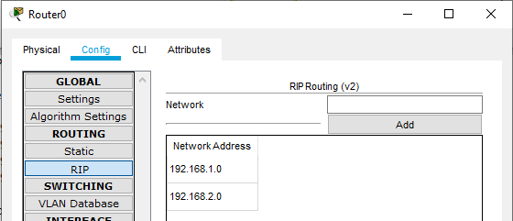

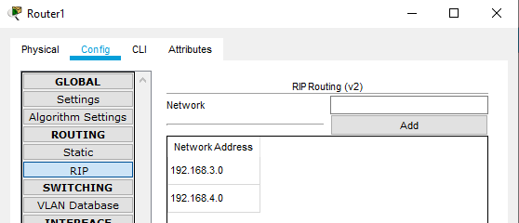

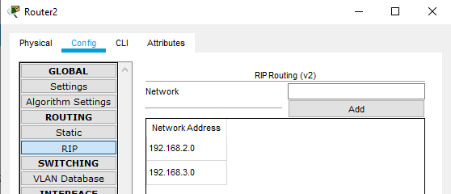

**Step 10 : Pass the message from one pc to another and observe the output**

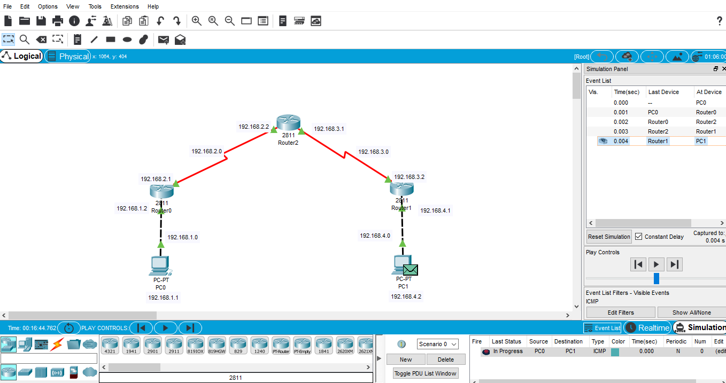

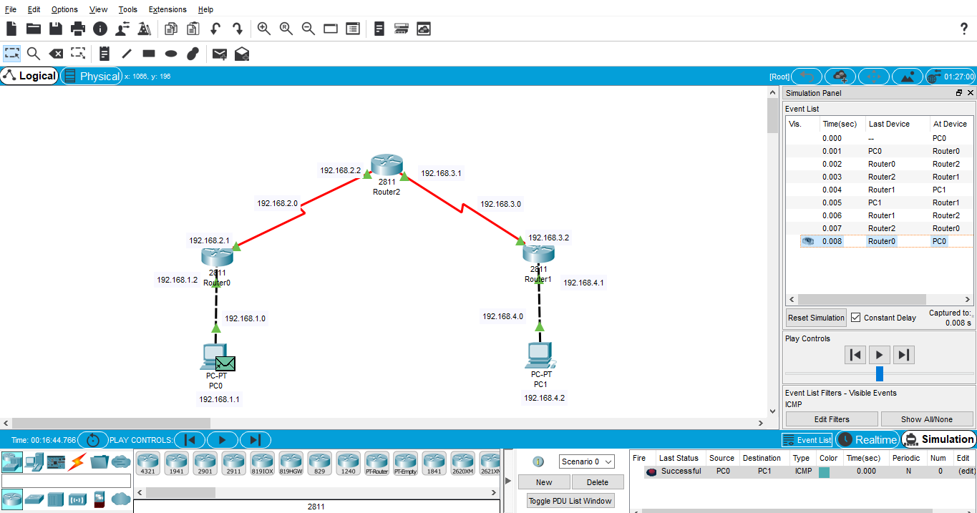

**Step 11: Create a connection between Network and assign IP address.**

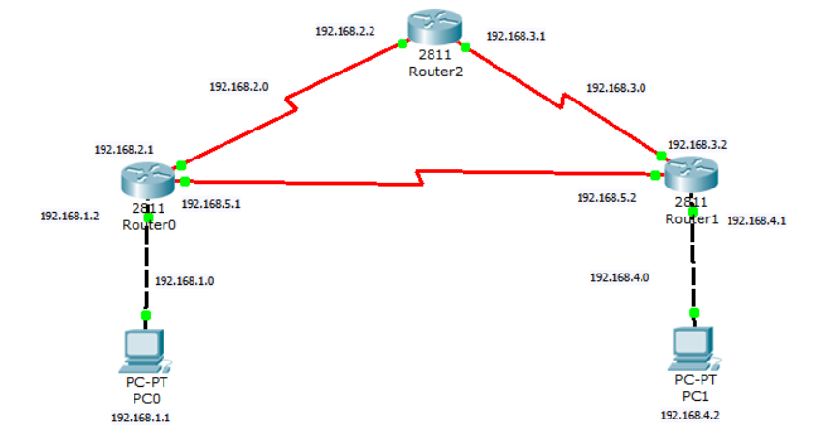

**Step 12 : Take next protocol EIGRP.**

**c. EIGRP**

**Router0:**

Router>en

Router#config t

Enter configuration commands, one per line. End with CNTL/Z.

Router(config)#router eigrp 1

Router(config-router)#network 192.168.1.0

Router(config-router)#network 192.168.2.0

Router(config-router)#network 192.168.5.0

**Router1:**

Router>en

Router#config t

Enter configuration commands, one per line. End with CNTL/Z.

Router(config)#router eigrp 1

Router(config-router)#network 192.168.3.0

Router(config-router)#network 192.168.4.0

Router(config-router)#network 192.168.5.0

**Router2:**

Router>en

Router#config t

Enter configuration commands, one per line. End with CNTL/Z.

Router(config)#router eigrp 1

Router(config-router)#network 192.168.2.0

Router(config-router)#network 192.168.3.0

**Step 13: Check the connections of routers after configuration as shown below (using commands)**

**Show Router0 route:**

Router>show ip route

Codes: C - connected, S - static, I - IGRP, R - RIP, M - mobile, B - BGP

D - EIGRP, EX - EIGRP external, O - OSPF, IA - OSPF inter area

N1 - OSPF NSSA external type 1, N2 - OSPF NSSA external type 2

E1 - OSPF external type 1, E2 - OSPF external type 2, E - EGP

i - IS-IS, L1 - IS-IS level-1, L2 - IS-IS level-2, ia - IS-IS inter area

* - candidate default, U - per-user static route, o - ODR

P - periodic downloaded static route

Gateway of last resort is not set

D 192.168.1.0/24 [90/20514560] via 192.168.2.1, 00:06:55, Serial0/3/0

C 192.168.2.0/24 is directly connected, Serial0/3/0

C 192.168.3.0/24 is directly connected, Serial0/2/0

D 192.168.4.0/24 [90/20514560] via 192.168.3.2, 00:06:56, Serial0/2/0

D 192.168.5.0/24 [90/21024000] via 192.168.3.2, 00:06:55, Serial0/2/0

[90/21024000] via 192.168.2.1, 00:06:55, Serial0/3/0

**Show Router1 route:**

Router>show ip route

Codes: C - connected, S - static, I - IGRP, R - RIP, M - mobile, B - BGP

D - EIGRP, EX - EIGRP external, O - OSPF, IA - OSPF inter area

N1 - OSPF NSSA external type 1, N2 - OSPF NSSA external type 2

E1 - OSPF external type 1, E2 - OSPF external type 2, E - EGP

i - IS-IS, L1 - IS-IS level-1, L2 - IS-IS level-2, ia - IS-IS inter area

* - candidate default, U - per-user static route, o - ODR

P - periodic downloaded static route

Gateway of last resort is not set

C 192.168.1.0/24 is directly connected, FastEthernet0/0

C 192.168.2.0/24 is directly connected, Serial0/3/0

D 192.168.3.0/24 [90/21024000] via 192.168.5.2, 00:05:06, Serial0/2/0

[90/21024000] via 192.168.2.2, 00:05:06, Serial0/3/0

D 192.168.4.0/24 [90/20514560] via 192.168.5.2, 00:05:06, Serial0/2/0

C 192.168.5.0/24 is directly connected, Serial0/2/0

**Show Router2 route:**

Router>show ip route

Codes: C - connected, S - static, I - IGRP, R - RIP, M - mobile, B - BGP

D - EIGRP, EX - EIGRP external, O - OSPF, IA - OSPF inter area

N1 - OSPF NSSA external type 1, N2 - OSPF NSSA external type 2

E1 - OSPF external type 1, E2 - OSPF external type 2, E - EGP

i - IS-IS, L1 - IS-IS level-1, L2 - IS-IS level-2, ia - IS-IS inter area

* - candidate default, U - per-user static route, o - ODR

P - periodic downloaded static route

Gateway of last resort is not set

D 192.168.1.0/24 [90/20514560] via 192.168.5.1, 00:07:28, Serial0/2/0

D 192.168.2.0/24 [90/21024000] via 192.168.5.1, 00:07:28, Serial0/2/0

[90/21024000] via 192.168.3.1, 00:07:28, Serial0/3/0

C 192.168.3.0/24 is directly connected, Serial0/3/0

C 192.168.4.0/24 is directly connected, FastEthernet0/0

C 192.168.5.0/24 is directly connected, Serial0/2/0

**Step 14: Ping Destination PC from Source PC**

PC>ping 192.168.4.2

Pinging 192.168.4.2 with 32 bytes of data:

Reply from 192.168.4.2: bytes=32 time=12ms TTL=126

Reply from 192.168.4.2: bytes=32 time=12ms TTL=126

Reply from 192.168.4.2: bytes=32 time=15ms TTL=126

Reply from 192.168.4.2: bytes=32 time=14ms TTL=126

Ping statistics for 192.168.4.2:

Packets: Sent = 4, Received = 4, Lost = 0 (0% loss),

Approximate round trip times in milli-seconds:

Minimum = 12ms, Maximum = 15ms, Average = 13ms

**Step 15: Take next protocol OSPF.**

**d. OSPF**

**Router0:**

Router>en

Router#config t

Enter configuration commands, one per line. End with CNTL/Z.

Router(config)#router ospf 1

Router(config-router)#network 192.168.1.0 0.0.0.255 area 0

Router(config-router)#network 192.168.2.0 0.0.0.255 area 0

Router(config-router)#network 192.168.5.0 0.0.0.255 area 0

**Router1:**

Router>en

Router#config t

Enter configuration commands, one per line. End with CNTL/Z.

Router(config)#router ospf 1

Router(config-router)#network 192.168.3.0 0.0.0.255 area 0

Router(config-router)#network 192.168.4.0 0.0.0.255 area 0

Router(config-router)#network 192.168.5.0 0.0.0.255 area 0

**Router2:**

Router>en

Router#config t

Enter configuration commands, one per line. End with CNTL/Z.

Router(config)#router ospf 1

Router(config-router)#network 192.168.2.0 0.0.0.255 area 0

Router(config-router)#network 192.168.3.0 0.0.0.255 area 0

**Step 16: Check the connections of routers after configuration as shown below (using commands)**

**Show Router0 route:**

Router>show ip route

Codes: C - connected, S - static, I - IGRP, R - RIP, M - mobile, B - BGP

D - EIGRP, EX - EIGRP external, O - OSPF, IA - OSPF inter area

N1 - OSPF NSSA external type 1, N2 - OSPF NSSA external type 2

E1 - OSPF external type 1, E2 - OSPF external type 2, E - EGP

i - IS-IS, L1 - IS-IS level-1, L2 - IS-IS level-2, ia - IS-IS inter area

* - candidate default, U - per-user static route, o - ODR

P - periodic downloaded static route

Gateway of last resort is not set

C 192.168.1.0/24 is directly connected, FastEthernet0/0

C 192.168.2.0/24 is directly connected, Serial0/3/0

O 192.168.3.0/24 [110/1562] via 192.168.2.2, 00:29:08, Serial0/3/0

[110/1562] via 192.168.5.2, 00:29:08, Serial0/2/0

O 192.168.4.0/24 [110/782] via 192.168.5.2, 00:08:14, Serial0/2/0

C 192.168.5.0/24 is directly connected, Serial0/2/0

**Show Router1 route:**

Router>show ip route

Codes: C - connected, S - static, I - IGRP, R - RIP, M - mobile, B - BGP

D - EIGRP, EX - EIGRP external, O - OSPF, IA - OSPF inter area

N1 - OSPF NSSA external type 1, N2 - OSPF NSSA external type 2

E1 - OSPF external type 1, E2 - OSPF external type 2, E - EGP

i - IS-IS, L1 - IS-IS level-1, L2 - IS-IS level-2, ia - IS-IS inter area

* - candidate default, U - per-user static route, o - ODR

P - periodic downloaded static route

Gateway of last resort is not set

O 192.168.1.0/24 [110/782] via 192.168.5.1, 00:10:03, Serial0/2/0

O 192.168.2.0/24 [110/1562] via 192.168.3.1, 00:29:08, Serial0/3/0

[110/1562] via 192.168.5.1, 00:28:58, Serial0/2/0

C 192.168.3.0/24 is directly connected, Serial0/3/0

C 192.168.4.0/24 is directly connected, FastEthernet0/0

C 192.168.5.0/24 is directly connected, Serial0/2/0

**Show Router2 route:**

Router>show ip route

Codes: C - connected, S - static, I - IGRP, R - RIP, M - mobile, B - BGP

D - EIGRP, EX - EIGRP external, O - OSPF, IA - OSPF inter area

N1 - OSPF NSSA external type 1, N2 - OSPF NSSA external type 2

E1 - OSPF external type 1, E2 - OSPF external type 2, E - EGP

i - IS-IS, L1 - IS-IS level-1, L2 - IS-IS level-2, ia - IS-IS inter area

* - candidate default, U - per-user static route, o - ODR

P - periodic downloaded static route

Gateway of last resort is not set

O 192.168.1.0/24 [110/782] via 192.168.2.1, 00:10:03, Serial0/3/0

C 192.168.2.0/24 is directly connected, Serial0/3/0

C 192.168.3.0/24 is directly connected, Serial0/2/0

O 192.168.4.0/24 [110/782] via 192.168.3.2, 00:08:14, Serial0/2/0

O 192.168.5.0/24 [110/1562] via 192.168.2.1, 00:29:08, Serial0/3/0

[110/1562] via 192.168.3.2, 00:29:08, Serial0/2/0

**Step 17: Pass the message From one pc to another and observe the output.**

